Proforma : 6

SURVEY OF DEPARTMENT OFFERING Ph.D. PROGRAMS | 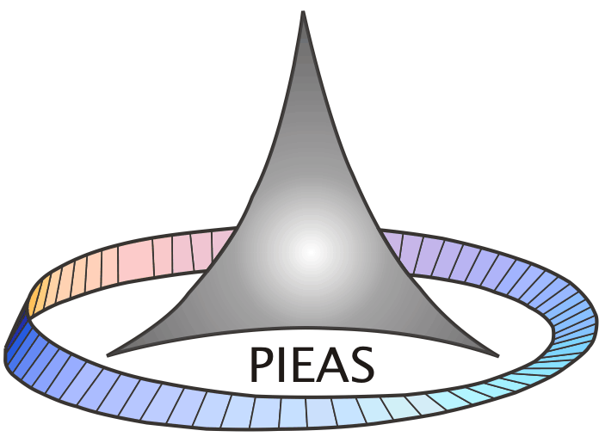

The following information is required for EACH Department in which a Ph.D. program is offered.

1 | General Information:
1.1 | Name of Department
1.2 | Name of Faculty
1.3 | Date of initiation of Ph.D. program
1.4 | Total number of academic journals subscribed in area relevant to Ph.D. program.
1.5 | Number of Computers available per Ph.D. student
1.6 | Total Internet Bandwidth available to all the students in the Department.
2 | Faculty Resources:
2.1 | Number of faculty members holding Ph.D. degree in the department.
2.2 | Number of HEC approved Ph.D. Advisors in the department.
3 | Research Output:
3.1 | Total number of articles published last year in International Academic Journals that are authored by faculty members and students in the department.
3.2 | Total number of articles published last year in Asian Academic Journals that are authored by faculty members and students in the department.
3.3 | Total number of ongoing research projects in the department funded by different organizations
3.4 | Number of post-graduate students in the department holding scholarships/fellowships.
3.5 | Total Research Funds available to the Department from all sources.
3.6 | Number of active international linkages involving exchange of researchers/students/faculty etc. (Attach Details).

4 | Student Information:
4.1 | Number of Ph.D. degrees conferred to date to students from the Department during the past three academic years.
4.2 | Number of Ph.D. students currently enrolled in the department.
4.3 | Ratio of number of students accepted to total number of applicants for Ph.D. Program.
5 | Program Information
5.1 | Entrance requirements into Ph.D. Program (M.Sc. / M.Phil.) Indicate subjects or M.Sc. / M.Phil.
5.2 | Is your Ph.D. program based on research only? (Y/N)
5.3 | Maximum number of years in which a Ph.D. degree has to be completed after initial date of enrollment in Ph.D. program.
5.4 | Total number of post M.Sc. (16 year equivalent) courses required for Ph.D.
5.5 | Total number of M.Phil. level courses taught on average in a Term / Semester.
5.6 | Total number of Ph.D. level courses taught on average in a Term / Semester.
5.7 | Do your students have to take/write:
 | - Ph.D. Qualifying examination (Y/N)
 | - Comprehensive examination (Y/N)
 | - Research paper in HEC approved Journal
 | - Any other examination (Y/N)
5.8 | Total number of International examiners to which the Ph.D. dissertation is sent.
5.9 | How is the selection of an examiner from technologically advanced countries carried out?
5.10 | Is there a minimum residency requirement (on campus) for award of Ph.D. degree?
6 | Additional Information
6.1 | Any other information that you would like to provide.

