Proforma: 10

Teacher Evaluation Form  (To be filled by the student) | 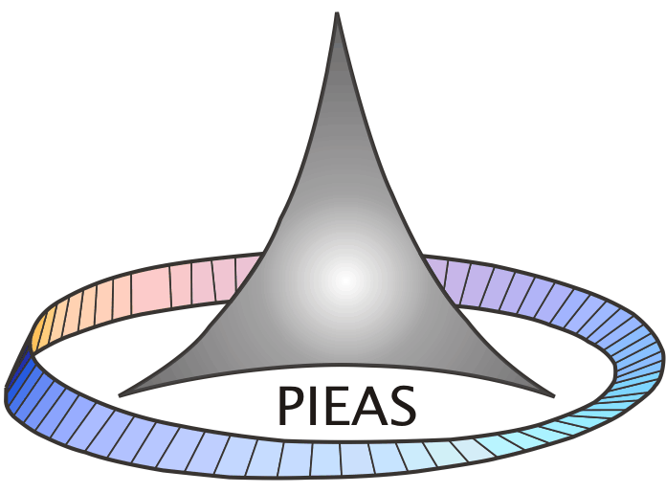

Course Title and Number: ____________________________________________
Name of Instructor: ________________________Semester___________________
Department: _____________________________Degree_______________________

Use the scale to answer the following questions below and make comments:
5: Strongly Agree | 4: Agree | 3: Uncertain | 2: Disagree | 1: Strongly Disagree

Instructor:
- The Instructor is prepared for each class
- The Instructor demonstrates knowledge of the subject
- The Instructor has completed the whole course
- The Instructor provides additional material apart from the textbook
- The Instructor gives citations regarding current situations with reference to Pakistani context.
- The Instructor communicates the subject matter effectively
- The Instructor shows respect towards students and encourages class participation
- The Instructor maintains an environment that is conducive to learning
- The Instructor arrives on time
- The Instructor leaves on time
- The Instructor is fair in examination
- The Instructor returns the graded scripts etc. in a reasonable amount of time
- The Instructor was available during the specified office hours and for after class consultations
Course:
- The Subject matter presented in the course has increased your knowledge of the subject
- The syllabus clearly states course objectives requirements, procedures and grading criteria
- The course integrates theoretical course concepts with real-world applications
- The assignments and exams covered the materials presented in the course
- The course material is modern and updated

Comments:
Instructor: ______________________________________________________________
_______________________________________________________________

Course: _______________________________________________________________
_______________________________________________________________
_______________________________________________________________

